1



DEPARTMENT OF COMPUTER SCIENCE AND ENGINEERING (CSE)

SRI VENKATESWARA COLLEGE OF ENGINERING & TECHNOLOGY (SVCET)

Fake News Detector Using NLP

*Final Project By*

P. Srinivasan (112421104050)

R. Anand Suman Singh (112421104005)

M. Vikram (112421104057)

J. Hariprasath (112421104019)

*Supervisor*

Divya

Lecturer, Dept. of CSE

A project submitted in partial fulfilment of the requirements for the degree of B.E. Engineering in Computer Science and Engineering

Academic Year: 2021-2025

# Declaration of Authorship

This is to certify that the work that was given has shown the outcome of the analysis and experiments below the superintendence of **Mrs. Divya**,

Lecturer of the Department of applied science and Engineering (CSE), Sri Venkateswara College of Engineering & Technology, Thirupachur, Tiruvallur. It's additionally declared that this project has not been submitted anyplace else for any degree or sheepskin. Info derived from the printed and unpublished work of others has been acknowledged

within the text and a listing of references is given.

**Authors**

R. Anand Suman Singh P. Srinivasan J. Hariprasath

ID : 112421104005 ID : 112421104050 ID : 112421104019

---------------------- ---------------------- ----------------------

M. Vikram K. Kiran Kumar

ID : 112421104057 ID : 1124211040

--------------------- ---------------------

# Acknowledgement

First and foremost, praises and thanks to Allah, the Almighty, for His showers of blessings throughout our project work to complete the project successfully.

We would like to express our deep and sincere gratitude to our supervisor, **Mrs. Divya**, Lecturer, Department of Computer Science & Engineering, Sri Venkateswara College of Engineering & Technology Technology, for allowing us to do the project and providing invaluable guidance throughout this project. We would be grateful for his guidance. His dynamism, vision, sincerity and motivation have deeply inspired us. He has taught us the methodology to carry out the project and to present the project works as clearly as possible. It was a great privilege and honour to work and study under his guidance. We are extremely grateful for what he has offered us. We would also like to thank him for his

friendship, empathy, and great sense of humour.

We would also like to thank our parents for being with us during the tough time of pandemic and ensuring that we receive the highest degree.

# Abstract

With the recent social media boom, the spread of fake news has become a great concern for everybody. It has been used to manipulate public opinions, influence the election - most notably the US Presidential Election of 2016, incite hatred and riots like the genocide of the Rohingya population. A 2018 MIT study found that fake news spreads six times faster on Twitter than real news. The credibility and trust in the news media are at an all-time low. It is becoming increasingly difficult to determine which news is real and which is fake. Various machine learning methods have been used to separate real news from fake ones. In this study, we tried to accomplish that using Passive Aggressive Classifier, LSTM and natural language processing. There are lots of machine learning models but these two

have shown better progress.

Now there is some confusion present in the authenticity of the correctness. But it definitely opens the window for further research. There are some of the aspects that has to be kept in mind considering the fact that fake news detection is not only a simple web interface but also a quite complex thing that includes a lot of backend work.

# Table of Content

**Declaration of Authorship** **2**

**Acknowledgement** **3**

**Abstract** **4**

**Table of Content** **5**

**Introduction** **6**

**2. Problem Statement** **7**

**3. Motivation** **8**

**4. Background Study** **11**

**5. Feasibility Study** **13**

**6. Methodology** **14**

6.1 The Dataset 14

6.2 The Machine Learning Model 15

6.3 The Web Interface 18

6.4 Common Platform: Flask 18

**7. Implementation** **19**

7.1 The Interface 19

7.2 The ML Model 21

7.3 Flask Code 34

7.4 Web Interface 37

**8. Key Insights** **42**

**9. Conclusion** **43**

**10. Future Work** **44**

**11. References** **45**

# 1.Introduction

Fake news is untrue information presented as news. It often has the aim of damaging the reputation of a person or entity or making money through advertising revenue. Once common in print, the prevalence of fake news has increased with the rise of social media, especially the Facebook News Feed. During the 2016 US presidential election, various kinds of fake news about the candidates widely spread in the online social networks, which may have a significant effect on the election results. According to a post-election statistical report, online social networks account for more than 41.8% of the fake news data traffic in the election, which is much greater than the data traffic shares of both traditional TV/radio/print medium and online search engines respectively. Fake news detection is becoming increasingly difficult because people who have ill intentions are writing the fake pieces so convincingly that it is difficult to separate from real news. What we have done is a simplistic approach that looks at the news headlines and tries to predict whether they may be fake or not.

Fake news can be intimidating as they attract more audience than normal. People use them because this can be a very good marketing strategy. But the money

earned might not live upto fact that it can harm people.

# Problem Statement

In this day and age, it is extremely difficult to decide whether the news we come across is real or not. There are very few options to check the authenticity and all of them are sophisticated and not accessible to the average person. There is an acute need for a web-based fact-checking platform that harnesses the power of Machine

Learning to provide us with that opportunity.

# Motivation

Social media facilitates the creation and sharing of information that uses computer-mediated technologies. This media changed the way groups of people interact and communicate. It allows low cost, simple access and fast dissemination of information to them. The majority of people search and consume news from social media rather than traditional news organizations these days. On one side, where social media have become a powerful source of information and bringing people together, on the other side it also 1 put a negative impact on society. Look at some examples herewith; Facebook Inc’s popular messaging service, WhatsApp became a political battle-platform in Brazil’s election. False rumours, manipulated photos, de-contextualized videos, and audio jokes were used for campaigning. These kinds of stuff went viral on the digital platform without monitoring their origin or reach. A nationwide block on major social media and messaging sites including Facebook and Instagram was done in Sri Lanka after multiple terrorist attacks in the year 2019. The government claimed that “false news reports” were circulating online. This is evident in the challenges the world's most powerful tech companies face in reducing the spread of misinformation. Such examples show that Social Media enables the widespread use of “fake news” as well. The news disseminated on social media platforms may be of low quality carrying misleading information intentionally. This sacrifices the credibility of the information. Millions of news articles are being circulated every day on the Internet – how one can trust which is real and which is fake? Thus incredible or fake news is one of the biggest challenges in our digitally connected world. Fake news detection on social media has recently become an emerging research domain. The domain focuses on dealing with the sensitive issue of preventing the spread of fake news on social media. Fake news identification on social media faces several challenges. Firstly, it is difficult to collect fake news data. Furthermore, it is difficult to label fake news manually. Since they are intentionally written to mislead readers, it is difficult to detect them simply based on news content. Furthermore, Facebook, Whatsapp, and Twitter are closed messaging apps. The misinformation disseminated by trusted news outlets or their friends and family is therefore difficult to be considered as fake. It is not easy to verify the credibility of newly emerging and time-bound news as they are not sufficient to train the application dataset. Significant approaches to differentiate credible users, extract useful news features and develop authentic information dissemination systems are some useful domains of research and need further investigations. If we can’t control the spread of fake news, the trust in the system will collapse. There will be widespread distrust among people. There will be nothing left that can be objectively used. It means the destruction of political and social coherence. We wanted to build some sort of web-based system that can fight this nightmare scenario. And we made

some significant progress towards that goal.

# Background Study

From an NLP perspective, researchers have studied numerous aspects of the credibility of online information. For example, [1] applied the time-sensitive supervised approach by relying on tweet content to address the credibility of a tweet in different situations. [2] used LSTM in a similar problem of early rumour detection. In another work, [3] aimed at detecting the stance of tweets and determining the veracity of the given rumour with convolution neural networks. A submission [4] to the SemEval 2016 Twitter Stance Detection task focuses on creating a bag-of-words autoencoder and training it over the tokenized tweets. Another team, [5], combined multiple models in an ensemble providing a 50/50 weighted average between a deep convolutional neural network and a

gradient-boosted decision tree. Though this work seems to be similar to our work, the difference lies in the construction of an ensemble of classifiers. In a similar attempt, a team [6] concatenated various features vectors and passed them through an NLP model. Passive Aggressive algorithm is a margin-based online learning algorithm for binary classification. It is also an algorithm of a soft margin-based method and robust to noise. It can be used in fake news detection [16] Term

Frequency-Inverse Document Frequency is also a method used to represent text in a format that can be easily processed by machine learning algorithms. It is a numerical statistic that shows how important a word is to news in a news dataset. The importance of a word is proportional to the number of times the word appears in the news (fake and real) but inversely proportional to the number of times the

word appears in the news dataset (fake or real) [15]

# Feasibility Study

Passive-aggressive classifier, logistic regression, LSTM can be used in fake news detection. Bi-directional LSTM was used in [7] to detect fake news. It had reasonably good accuracy but if the news was a bit more sophisticated, it would be difficult to achieve good accuracy. Because this model picks up the

sensational/clickbaity words as part of fake news. For example, if a news title says, ‘Donald Trump is the greatest president ever, the model will pick it up as fake news with reasonable accuracy. If the title is more nuanced and written in a sophisticated way, it’d be difficult to do so. We believe that our LSTM model is not enough by itself to detect fake news. That’s why we included passive aggressive classifier with it and when we compared passive news with reputable news sources, but the scope of the work is so vast that we couldn’t do it with the resources available to us. Our model can act as a first step in detecting fake news.

But more work is needed to call the model reliable enough.

# Methodology

## The Dataset



Figure 1 : Dataset

The dataset is simple. It contains the titles of the news, the body text and a label field, which, if the news is authentic, shows REAL and if inauthentic, shows FAKE.

There are 3 main segments of the methodology :

◦ The core Machine Learning model.

◦ The web interface.

◦ The common platform that brings the model and the interface together.

## The Machine Learning Model

There are two parts to the ML Model building. Machine Learning is a part of our life that can help us in predicting. We are using two types of model in this case. For

the first part, we used passive-aggressive classifiers. And the steps include:

1. **Data Loading:** We are loading a CSV file for the data sorting and

training-testing part of the model. The CSV file is turned into an array for easier work purpose.

1. **Vectorization:** Vectorization is needed for determining the frequency of the words present in a passage. This is needed to determine which words are

used often.

1. **Classifier:** Passive-aggressive algorithms are a family of great learning algorithms. They are similar to Perceptron because it does not require a reading scale. However, unlike Perceptron, they include parameter correction. Passive is used when the prediction is correct and there is no change in the model. But if there is any kind of change in the model, that is if the prediction is not correct then the aggressive part is called, which changes the model accordingly. The aggressive part of the model changes

the model according to its wish on the backend.

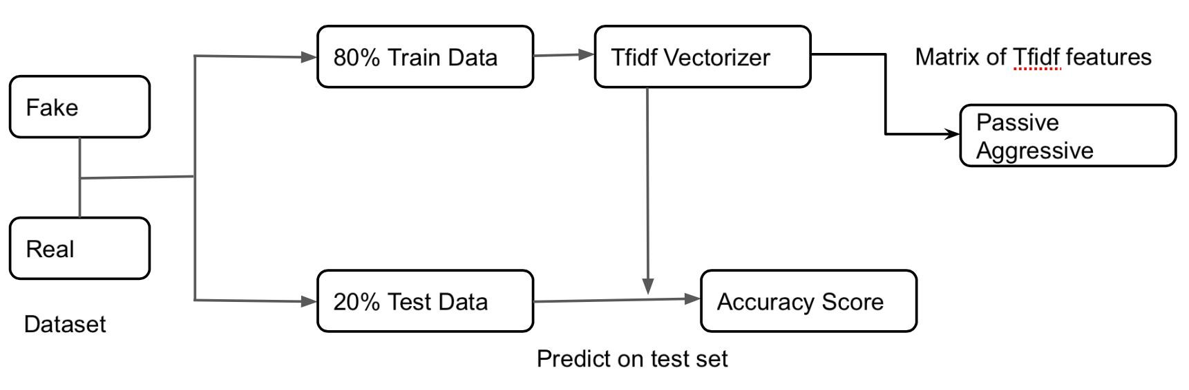

Figure 2 : Passive-aggressive model

1. **Model Building:** The model is built through the train and test of the dataset, by ensuring that the training is done for 80% of the dataset and testing is

done in the rest of the 20% of the dataset.

In the second part, we used is LSTM. Here are the steps :

1**. Loading the data:** For this step, it is the same as the passive-aggressive one.

2.**Scanning and parsing.** Data is loaded from a CSV file. This consists of the body of selected news articles. It then contains a label field that indicates whether the news is real or fake. In this code block, we scan the CSV and

clean the titles to filter out stop words and punctuation.

1. **Tokenization.** The tokenizer is used to assign indices to words, and filter out infrequent words. This allows us to generate sequences for our training

and testing data.

1. **Embedding matrix:** Apply the embedding matrix. An embedding matrix

is used to extract the semantic information from the words in each title.

1. **Model Building:** Building the model and finding out the accuracy via confusion matrix. The model is created using an Embedding layer, LSTM, Dropout, and Dense layers. We are going to run the data on 20 epochs.

We observed that the LSTM model is vastly inaccurate in predicting the authenticity of the news. So we decided to show the output by running it

through the Passive-aggressive classifier model.

## The Web Interface

This was the simplest part.

1. **HTML for building the basic skeleton**: HTML makes the structure of the web application and also there are some of the functions that can be

achieved best with HTML only.

1. **CSS for design**: The CSS part is for designing only. Because it will give a

more beautiful aspect to the website.

## Common Platform: Flask

This acts as a common platform and takes the input with the pickle module and passes it to the machine learning model afterwards the prediction is shown on the screen with the HTML and CSS website.

1. Building functions for taking input.
2. Passing input values through the ML model.
3. Using the Pickle module for serializing and de-serializing the dataset.
4. Providing output.

# Implementation

## The Interface

This is what you see when you go to the web interface. You are supposed to copy

the news and paste it into the input box.

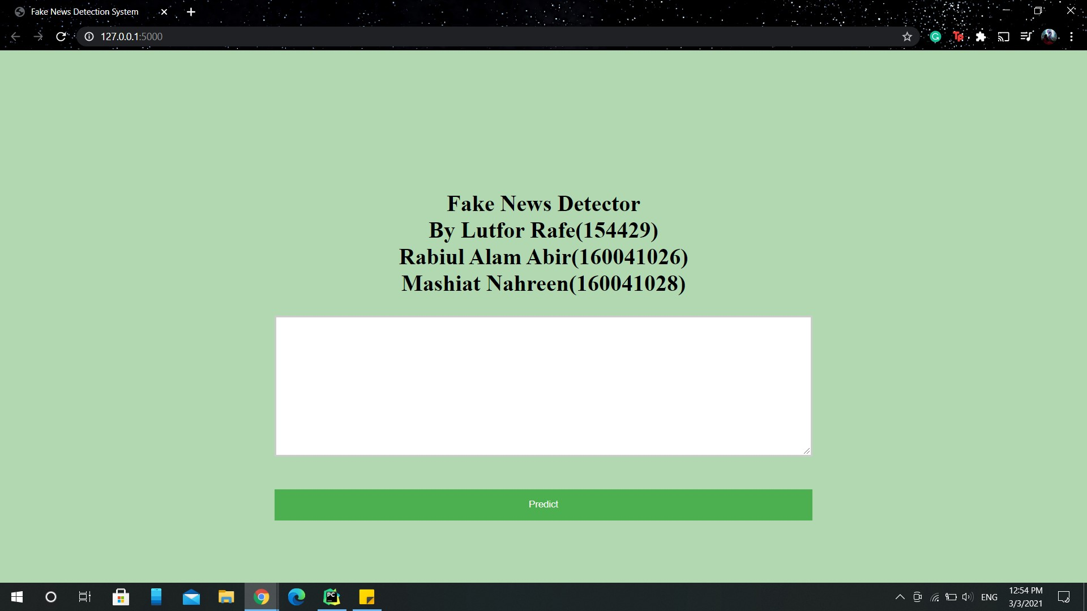

Figure 3.1 : The Interface

When you paste the news on the input box and click ‘Predict’ the model will give you the result. If the news seems authentic, the output will be ‘Looking Real News’. Otherwise, it will show ‘Looking Fake News’. That’s how you can detect

fake or real news via the interface.

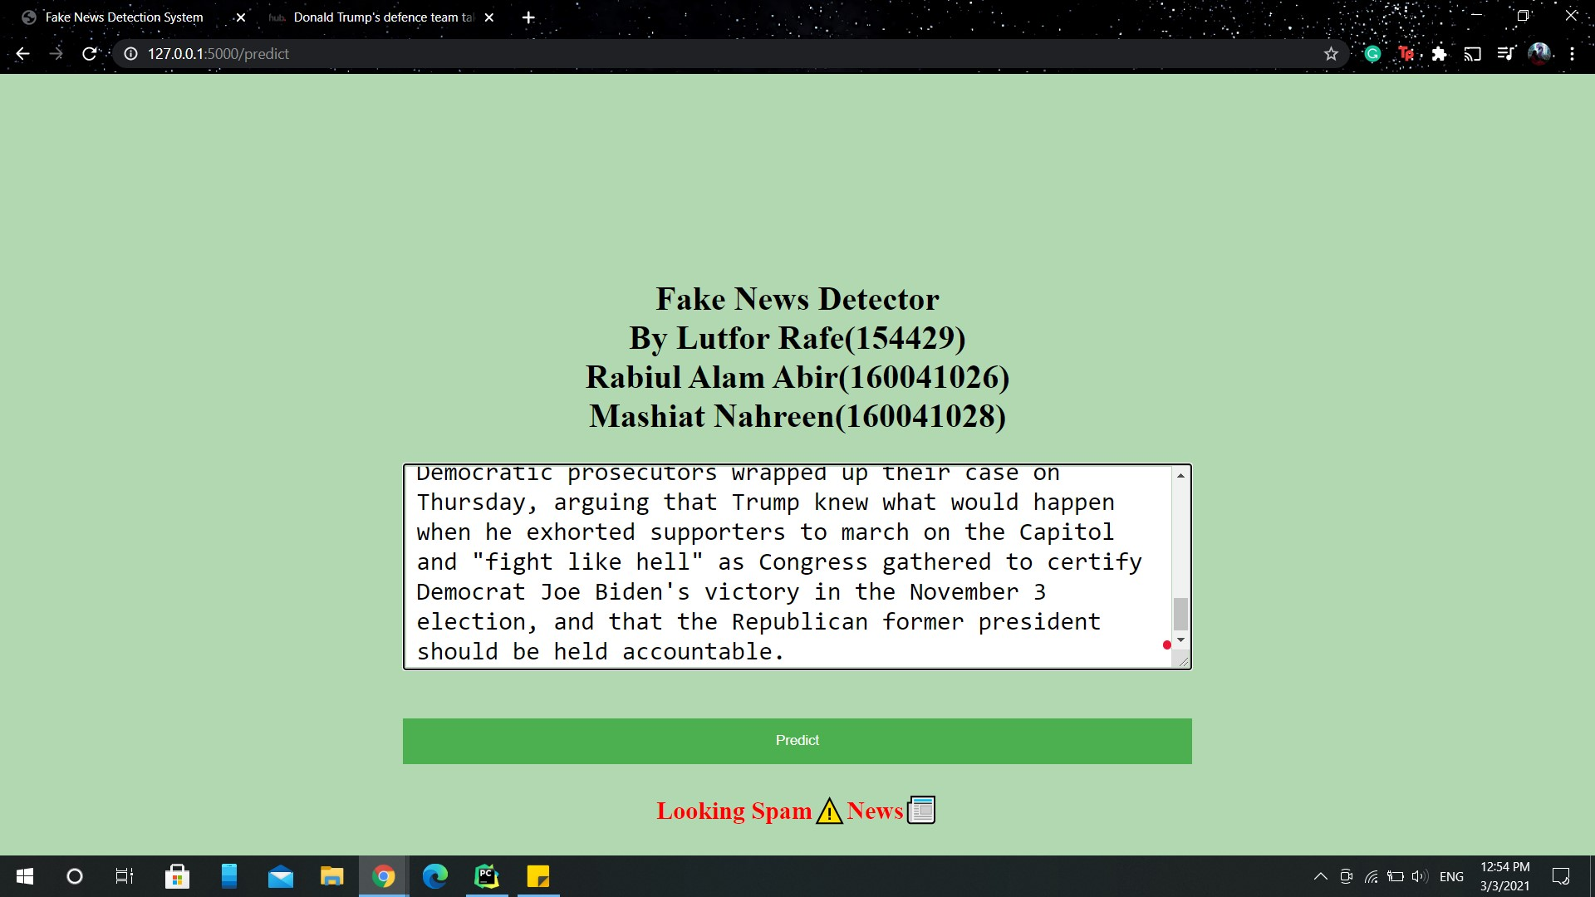

Figure 3.2 : The Interface

## The ML Model

The code for the ML model building is as follows:

TF-IDF stands for Term Frequency-Inverse Document Frequency. Term frequency is basically a ratio of the number of times a particular word appears with respect to the total number of word. And Inverse Document Frequency is basically the weight

of a rare word.

from sklearn.feature_extraction.text import

TfidfVectorizer text = ['This is the final project of Mashiat Nahreen, Lutfor Rafe and Rabiul Alam Abir', 'This is the final project of our undergrad.' ] vectorization = TfidfVectorizer() vectorization.fit(text) print(vectorization.idf_) print(vectorization.vocabulary_)

Words that are present in every data will have very low IDF value and using that we will highlight the maximum IDF values.

example = text[0]

example example = vectorization.transform([example]) print(example.toarray())

The zeros represent there are no words in that postion.

IMPLEMENTING PASSIVE AGGRESSIVE CLASSIFIER

Passive is used when the prediction is correct and there is no change in the model. But if there is any kind of change in the model that is if the prediction is not correct then aggressive part is called, which changes the model accordingly.

import os os.chdir("D:\Books\Fake_News_Detection-master")

OS module is used for the Python program to interact with the operating system

import pandas as pd dataset = pd.read_csv('news.csv') dataset.head() x = dataset['text'] y = dataset['label'] x y from sklearn.model_selection import train_test_split

|  |  |
| --- | --- |
| from sklearn.feature_extraction.text  TfidfVectorizer | import |
| from sklearn.linear_model | import |

PassiveAggressiveClassifier

from sklearn.metrics import accuracy_score,

confusion_matrix

x_train,x_test,y_train,y_test =

train_test_split(x,y,test_size=0.2,random_state=0) y_train y_train

vectorization =

TfidfVectorizer(stop_words='english',max_df=0.7) xv_train = vectorization.fit_transform(x_train) xv_test = vectorization.transform(x_test)

max_df refers to the percentage of the repetition of the word. 0.7 means 70% of the

time the word is repeated.

classifier = PassiveAggressiveClassifier(max_iter=50) classifier.fit(xv_train,y_train) y_pred = classifier.predict(xv_test)

score = accuracy_score(y_test,y_pred) print(f'Accuracy: {round(score*100,2)}%')

cf = confusion_matrix(y_test,y_pred,

labels=['FAKE','REAL']) print(cf) def fake_news_det(news):

input_data = [news]

|  |  |
| --- | --- |
| vectorized_input_data  vectorization.transform(input_data) | = |
| prediction | = |

classifier.predict(vectorized_input_data) print(prediction) fake_news_det('U.S. Secretary of State John F. Kerry said Monday that he will stop in Paris later this week, amid criticism that no top American officials

attended Sundayâ€™s unity march against terrorism.') fake_news_det("""Go to Article

President Barack Obama has been campaigning hard for the woman who is supposedly going to extend his legacy four more years. The only problem with stumping for Hillary Clinton, however, is sheâ€™s not exactly a

candidate easy to get too enthused about. """) import pickle pickle.dump(classifier,open('model.pkl', 'wb')) pickle is used for serializing and deserializing any

data that is inputted in Python.

loaded_model = pickle.load(open('model.pkl', 'rb')) def fake_news_det1(news):

input_data = [news]

|  |  |
| --- | --- |
| vectorized_input_data  vectorization.transform(input_data) | = |
| prediction | = |

classifier.predict(vectorized_input_data) print(prediction) fake_news_det1("""U.S. Secretary of State John F. Kerry said Monday that he will stop in Paris later this week, amid criticism that no top American officials attended Sundayâ€™s unity march against

terrorism.""") fake_news_det('''U.S. Secretary of State John F. Kerry said Monday that he will stop in Paris later this week, amid criticism that no top American officials

attended Sundayâ€™s unity march against terrorism.''')

In this project, titles of news articles found on the internet is used to determine whether a news is fake or real. We are using LSTM to help classify them into either

real or fake category.

import numpy as np import pandas as pd import json as j import urllib import gzip import nltk nltk.download('stopwords') from nltk.stem import PorterStemmer from sklearn.model_selection import train_test_split

!pip install gensim

from gensim.models import KeyedVectors from nltk.corpus import stopwords from keras.models import Model

from keras.callbacks import EarlyStopping,

ModelCheckpoint

from keras.layers import Dense, Input, LSTM,

Embedding, Dropout, Activation from keras.layers.merge import concatenate

from keras.layers.normalization import

BatchNormalization from keras.preprocessing import sequence from keras.preprocessing.text import Tokenizer from keras.preprocessing.sequence import pad_sequences

Data scanning and parsing : Data is loaded from a csv file fake_or_real_news.csv. This consists of the title and text of a select group of news articles. It then contains a label field which indicates whether the news is real or fake. In this code block,

we scan the csv and clean the titles to filter out stop words and punctuation.

import re import string from sklearn.feature_extraction.text import

CountVectorizer def clean_text(text): text = str(text)

text = text.split() words = [] for word in text:

exclude = set(string.punctuation)

word = ''.join(ch for ch in word if ch not in

exclude) if word in stops:

continue try:

words.append(ps.stem(word)) except UnicodeDecodeError:

words.append(word) text = " ".join(words) return text.lower() stops = set(stopwords.words("english")) ps = PorterStemmer() f = pd.read_csv('news.csv')

f.label = f.label.map(dict(REAL=1, FAKE=0)) f

We take the news titles and divide the train and test set. We also clean the text.

f = f[1:100]

X_train, X_test, y_train, y_test =

train_test_split(f['title'], f.label, test_size=0.2) X_cleaned_train = [clean_text(x) for x in X_train]

X_cleaned_test = [clean_text(x) for x in X_test]

X_cleaned_train[0]

Tokenizer : Tokenizer is used to assign indices to words, and filter out infrequent words. This allows us to generate sequences for our training and testing data.

import tokenize from keras.preprocessing.text import Tokenizer MAX_NB_WORDS = 20000 tokenizer = Tokenizer(num_words=MAX_NB_WORDS)

|  |  |
| --- | --- |
| tokenizer.fit_on_texts(X_cleaned_train X_cleaned_test) print('Finished Building Tokenizer') | + |
| train_sequence tokenizer.texts_to_sequences(X_cleaned_train) print('Finished Tokenizing Training') | = |
| test_sequence | = |

tokenizer.texts_to_sequences(X_cleaned_test) print('Finished Tokenizing Training')

Embedding Matrix : Embedding matrix is used to extract the semantic information

from the words in each title.

from gensim.models import KeyedVectors from gensim.models import Word2Vec

EMBEDDING_FILE =

'https://s3.amazonaws.com/dl4j-distribution/GoogleNews

-vectors-negative300.bin.gz'

Word2Vec =

KeyedVectors.load_word2vec_format(EMBEDDING_FILE, binary=True)

word_index = tokenizer.word_index print('Found %s unique tokens' % len(word_index)) nb_words = min(20000, len(word_index)) embedding_matrix = np.zeros((nb_words, 300)) for word, i in word_index.items():

try:

embedding_vector = word2vec.word_vec(word) if embedding_vector is not None and i < 7000:

embedding_matrix[i] = embedding_vector except (KeyError, IndexError) as e:

continue

Building the Model : The model is created using an Embedding layer, LSTM,

Dropout, and Dense layers.We are going to run the data on 20 epochs.

from keras.models import Sequential from keras.layers import Dense, LSTM, Dropout, Conv1D, MaxPooling1D from keras.layers.embeddings import Embedding from keras.preprocessing import sequence from keras.preprocessing.sequence import pad_sequences kVECTORLEN = 50 model = Sequential() model.add(Embedding(5000, 500, input_length=50)) model.add(Dropout(0.4)) model.add(Dense(1, activation='relu')) model.compile(loss='binary_crossentropy', optimizer='adam', metrics=['accuracy']) print(model.summary())

train_sequence =

sequence.pad_sequences(train_sequence, maxlen=50) test_sequence = sequence.pad_sequences(test_sequence, maxlen=50)

history = model.fit(train_sequence, y_train, validation_data=(test_sequence, y_test), epochs=20, batch_size=64)

Calculating the accuracy.

scores = model.evaluate(test_sequence, y_test,

verbose=0)

accuracy = (scores[1]*100) print("Accuracy: {:.2f}%".format(scores[1]*100))

Analyzing the Data: The graphs below demonstrate the change in accuracy and

loss for the training data as well as the validation data.

import matplotlib.pyplot as plt plt.plot(history.history['accuracy']) plt.plot(history.history['val_accuracy']) plt.title('model accuracy') plt.ylabel('accuracy') plt.xlabel('epoch') plt.legend(['train', 'validation'], loc='upper left') plt.show() plt.plot(history.history['loss']) plt.plot(history.history['val_loss']) plt.title('model loss') plt.ylabel('loss') plt.xlabel('epoch') plt.legend(['train', 'test'], loc='upper left') plt.show()

Fake News Detector 34

## Flask Code

from flask import Flask, render_template, request from sklearn.feature_extraction.text import

TfidfVectorizer

from sklearn.linear_model import

PassiveAggressiveClassifier import pickle import pandas as pd from sklearn.model_selection import train_test_split app = Flask(__name__) vectorization = TfidfVectorizer(stop_words='english', max_df=0.7) loaded_model = pickle.load(open('model.pkl', 'rb')) dataset = pd.read_csv('news.csv') x = dataset['text'] y = dataset['label'] x_train, x_test, y_train, y_test = train_test_split(x, y, test_size=0.2, random_state=0)

def fake_news_det(news):

xv_train = vectorization.fit_transform(x_train) xv_test = vectorization.transform(x_test) input_data = [news]

vectorized_input_data =

vectorization.transform(input_data)

prediction =

loaded_model.predict(vectorized_input_data) return prediction @app.route('/') def home():

return render_template('index.html') @app.route('/predict', methods=['POST']) def predict():

if request.method == 'POST': message = request.form['message'] pred = fake_news_det(message) print(pred)

return render_template('index.html',

prediction=pred) else:

return render_template('index.html',

prediction="Something went wrong") if __name__ == '__main__': app.run(debug=True)

## Web Interface

<!DOCTYPE html>

<html>

<head>

<meta charset="UTF-8">

<title>Fake News Detection System</title>

<link href='https://fonts.googleapis.com/css?family=Pacifico

' rel='stylesheet' type='text/css'>

<link href='https://fonts.googleapis.com/css?family=Arimo' rel='stylesheet' type='text/css'>

<link href='https://fonts.googleapis.com/css?family=Hind:300

' rel='stylesheet' type='text/css'>

<link href='https://fonts.googleapis.com/css?family=Open+San s+Condensed:300' rel='stylesheet' type='text/css'> <meta name="viewport" content="width=device-width, initial-scale=1">

<style> input[type=text], select, textarea { width: 50%; padding: 10px; border: 3px solid #ccc; border-radius: 1px; box-sizing: border-box; margin-top: 6px; margin-bottom: 16px; resize: horizontal;

} button { background-color: #4CAF50; color: white; padding: 14px 20px; margin: 8px 0; border: none;

cursor: pointer; width: 50%; } button:hover { opacity: 0.8;

}

h1 {

text-align: center;

}

p {

text-align: center;

}

div { text-align: center; } body {

background: rgba(0, 128, 0, 0.3) /* Green

background with 30% opacity */

}

</style>

</head>

<body>

<p style="padding: 0 10em 10em 0">

<div class="login">

<h1 style="text-align:center;">Fake News Detector

</br> By Lutfor Rafe(154429) </br> Rabiul Alam

Abir(160041026) </br> Mashiat

Nahreen(160041028) </h1>

<form action="{{ url_for('predict')}}" method="POST">

<textarea name="message" rows="6" cols="20" required="required" style="font-size:

18pt"></textarea> <br> </br>

<button type="submit" class="btn btn-primary btn-block btn-large">Predict</button>

<div class="results">

{% if prediction == ['FAKE']%}

<h2 style="color:red;">Looking Spam⚠News📰

</h2>

{% elif prediction == ['REAL']%}

<h2 style="color:green;"><b>Looking Real

News📰</b></h2>

{% endif %}

</div>

</form>

</div>

</p>

</body>

</html>

# Key Insights

The passive aggressive model produces 93% accuracy. When we input the news text on the interface, it correctly identifies the news most of the time. We tested this by using news from The Onion. The Onion is a satire ‘news’ portal that posts fake funny news. When we pasted some of the news from the site on our web interface, those were correctly identified as fake. But when we wanted to test the news from BBC or New York Times, those were correctly identified as real. But the accuracy of the LSTM model was much lower, so we went with the Passive Aggressive

model to produce output on the interface.

# Conclusion

Our project can ring the initial alert for fake news. The model produces worse results if the article is written cleverly, without any sensationalization. This is a very complex problem but we tried to address it as much as we could. We believe the interface provides an easier way for the average person to check the authenticity of a news. Projects like this one with more advanced features should be integrated on social media to prevent the spread of fake news.

# Future Work

There are many future improvement aspects of this project. Introducing a cross checking feature on the machine learning model so it compares the news inputs with the reputable news sources is one way to go. It has to be online and done in real time, which will be very challenging. Improving the model accuracy using bigger and better datasets, integrating different machine learning algorithms is also something we hope to do in the future.

# References

1. C. Castillo, M. Mendoza, and B. Poblete. Predicting information credibility in time-sensitive social media. Internet Research, 23(5):560–588, 2013.
2. T. Chen, L. Wu, X. Li, J. Zhang, H. Yin, and Y. Wang. Call attention to rumours: Deep attention-based recurrent neural networks for early rumour

detection. arXiv preprint arXiv:1704.05973, 2017.

1. Y.-C. Chen, Z.-Y. Liu, and H.-Y. Kao. Ikm at several-2017 task 8: Convolutional neural networks for stance detection and rumour verification.

Proceedings of SemEval. ACL, 2017.

1. I. Augenstein, A. Vlachos, and K. Bontcheva. Usfd at semeval-2016 task 6:

Any-target stance detection on Twitter with autoencoders. In

SemEval@NAACL-HLT, pages 389–393, 2016.

1. S. B. Yuxi Pan, Doug Sibley. Talos. http://blog.talosintelligence. com/2017/06/, 2017.
2. B. S. Andreas Hanselowski, Avinesh PVS and F. Caspelherr. Team athene on

the fake news challenge. 2017.

1. Bahad, P., Saxena, P. and Kamal, R., 2019. Fake News Detection using Bi-directional LSTM-Recurrent Neural Network. Procedia Computer Science, 165, pp.74-82.
2. EANN: Event Adversarial Neural Networks for Multi-Modal
3. Fake News Detection on Social Media: A Data Mining Perspective Kai Shuy, Amy Slivaz, Suhang Wangy, Jiliang Tang \, and Huan Liuy
4. CSI: A Hybrid Deep Model for Fake News DetectionIdentifying the signs of fraudulent accounts using data mining techniques Shing-Han Li a,, David C. Yen b,1, Wen-Hui Luc,2, Chiang Wanga,2
5. Automatic Deception Detection: Methods for Finding Fake News. Niall J. Conroy, Victoria L. Rubin, and Yimin Chen
6. J. D'Souza, "An Introduction to Bag-of-Words in NLP," 03 04 2018. [Online].

Available:https://medium.com/greyatom/an-introduction-tobag-of-words-in-nlp-ac 967d43b428.

1. G. Bonaccorso, "Artificial Intelligence – Machine Learning – Data Science,"

10 06 2017.

[Online].Available:https://www.bonaccorso.eu/2017/10/06/mlalgorithms-addendu m-passive-aggressivealgorithms/